Sirena SUPER 30 Program

VOLUME 1
Sensors and Core Electronics in Robotics & Embedded Systems



Module Overview
This module teaches how a robot senses the world, from "what is a sensor?" combining several sensors into one reliable two-board system. It starts with the basic electronics every sensor needs (resistors, voltage dividers, pull-ups, filters) and then studies one sensor family per section: distance, environment, motion, light and position. It ends with RoboSense, a system in which an Arduino Uno collects sensor data and sends it to an ESP32 controller over a checked serial link.
Every topic is explained on both boards side by side: the 5 V, 8-bit Arduino Uno and the 3.3 V, 32-bit ESP32. Each section moves in the same order, from easy to advance:
- How it works: the physics that makes the sensor respond.
- The circuit and the math: how that response becomes a voltage, a pulse or a number.
- Connecting it: wiring on the Uno and on the ESP32, including safe 5 V to 3.3 V connections.
- Reading it in code: a short, non-blocking example that works on both boards.
- Common mistakes to avoid, followed by practice questions.

# | Topic | Main ideas
1 | Sensor Fundamentals and Core Electronics | Transduction, sensor specifications, ADC resolution, pull-ups, voltage dividers, op-amp buffers, Wheatstone bridge, RC and software filters
2 | Distance and Proximity Sensors | Ultrasonic time of flight (HC-SR04), infrared triangulation (Sharp GP2Y0A21), laser time of flight (VL53L0X)
3 | Environmental Sensors | Temperature and humidity (DHT22), dew point, gas sensing (MQ-2)
4 | Motion and Kinematic Sensors | PIR motion sensors, MPU6050 accelerometer and gyroscope, tilt angles, complementary filter
5 | Light and Optical Sensors | LDR, photodiode, phototransistor, TCS3200 colour sensor
6 | Position and Displacement Sensors | Potentiometers, quadrature encoders, direction, RPM with interrupts
7 | System Integration: RoboSense | Two-board architecture, checksummed UART messages, pin map, fail-safe design
Learning Outcomes
By the end of this module, learners will be able to:
- Explain what a sensor and a transducer are, and describe sensor specifications such as range, sensitivity, resolution, accuracy, and response time.
- Calculate voltage dividers, ADC values, filter cut-off frequencies, distances, dew points, tilt angles, and motor RPM.
- Design simple signal-conditioning circuits with pull-ups, dividers, op-amp buffers, and RC filters.
- Connect 5 V and 3.3 V sensors safely to both the Arduino Uno and the ESP32.
- Implement non-blocking sensor code with millis(), interrupts, volatile variables and safe (atomic) reads.
- Combine sensor readings using filters and the complementary filter.
- Describe how a two-board sensing system exchanges checksummed messages and stays safe when the link fails.
Hardware and Software Required
Item | Purpose
Arduino Uno R3 (ATmega328P) | 5 V, 8-bit reference board; RoboSense field node
ESP32 DevKitC (ESP32-WROOM-32) | 3.3 V, 32-bit dual-core board; RoboSense controller
HC-SR04, Sharp GP2Y0A21YK0F, VL53L0X | Ultrasonic, infrared and laser distance sensors
DHT22, MQ-2 module | Temperature/humidity and gas sensors
HC-SR501 PIR, MPU6050 (GY-521) | Motion detection and 6-axis IMU
LDR (GL5528), BPW34 photodiode, TCS3200 module | Light and colour sensors
10 kΩ potentiometer, 600 PPR quadrature encoder | Position and speed sensors
MCP6002 op-amp, resistors (1 kΩ–1 MΩ), capacitors (10 nF–100 µF) | Signal conditioning
BSS138 level shifter, 1 kΩ / 2 kΩ dividers | Safe 5 V to 3.3 V connections
Breadboard, jumper wires, multimeter, logic analyzer | Building and measuring circuits
Arduino IDE 2.x, Arduino-ESP32 core 3.x, Wokwi, PulseView | Software (all free)

Libraries used: Wire (built in), Pololu VL53L0X, Adafruit DHT sensor library. The MPU6050 is read with plain Wire register access, so no IMU library is needed.
Safety: never connect a 5 V signal directly to an ESP32 pin. The MQ-2 heater gets hot, so do not touch or cover it.

1. Sensor Fundamentals and Core Electronics
1.1 What Is a Sensor?
A sensor is a device that responds to a physical quantity, such as distance, light or temperature, and produces an electrical signal. The part that converts one form of energy into another is called the transducer. A thermistor turns heat into a change of resistance; a photodiode turns light into current; a piezo disc turns sound pressure into voltage.
Sensors can be grouped in three simple ways:
- Active or passive. An active sensor produces its own electrical signal (a photodiode makes current from light). A passive sensor only changes a property, such as resistance, and needs a supply voltage to be read (an LDR or a potentiometer).
- Analog or digital. An analog sensor gives a voltage that can take any value. A digital sensor contains its own converter and sends a number over a bus such as I2C, or encodes it as a pulse width or frequency.
- Contact or non-contact. A potentiometer touches the shaft it measures; an ultrasonic sensor never touches its target.
1.2 The Signal Chain
Every reading travels through the same chain: the physical quantity changes the transducer, a circuit turns that change into a clean voltage, the ADC turns the voltage into a number, and software filters the number before using it.
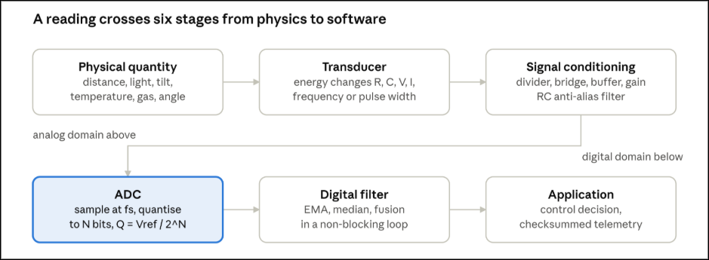An error can enter at any stage, so when a reading is wrong, check each stage in turn.
1.3 Sensor Specifications
Datasheets describe a sensor with a few standard terms:
- Range: the smallest to largest value it can measure (HC-SR04: 2 cm to 400 cm).
- Sensitivity: how much the output changes per unit of input, S = Δoutput ÷ Δinput. A temperature sensor giving 10 mV per °C has S = 10 mV/°C.
- Resolution: the smallest change the system can detect.
- Accuracy: how close a reading is to the true value.
- Precision (repeatability): how close repeated readings are to each other. A sensor that always reads 2 °C high is precise but not accurate; calibration fixes it.
- Offset: the output when the input is zero.
- Hysteresis: a different reading for the same input depending on whether the input was rising or falling.
- Response time: how quickly the output follows a change. Many sensors reach 63% of a step change after one time constant τ, and about 99% after 5τ.
1.4 Resistors, Ohm's Law and Kirchhoff's Laws
A resistor limits current. Its resistance depends on the material and its shape: R = ρL ÷ A, where ρ is resistivity, L is length and A is cross-section area. Many sensors work by changing one of these: a strain gauge stretches (L and A change), a thermistor and an LDR change their resistivity.
Three rules are enough to analyze every circuit in this module:
- Ohm's Law: V = I × R.
- Kirchhoff's Current Law (KCL): current flowing into a point equals current flowing out.
- Kirchhoff's Voltage Law (KVL): the voltages around any closed loop add up to zero.
1.5 Pull-up and Pull-down Resistors
A digital input with nothing connected floats: it picks up noise and reads random HIGH and LOW values. A pull-up resistor (often 10 kΩ) connects the pin to the supply, so it reads HIGH until a switch or sensor pulls it to ground. A pull-down resistor does the opposite. Both boards have internal pull-ups (INPUT_PULLUP): about 20–50 kΩ on the Uno and about 45 kΩ on the ESP32. Open-collector sensors, such as many encoders, only pull the line LOW and always need a pull-up.
A smaller pull-up gives faster, cleaner edges but wastes more current when the line is LOW: a 1 kΩ pull-up at 5 V wastes 5 mA.
1.6 The Voltage Divider
Two resistors in series form a voltage divider. The same current flows through both, so the output voltage across R2 is:

This is how resistive sensors (LDR, thermistor, potentiometer) are turned into a voltage. It also shifts a 5 V signal down for the ESP32: R1 = 1 kΩ and R2 = 2 kΩ give 5 × 2 ÷ 3 = 3.33 V.
Loading error (advanced). A divider only gives the correct voltage if the circuit reading it draws almost no current. Seen from its output, the divider acts like a source with resistance R1 × R2 ÷ (R1 + R2). With R1 = R2 = 100 kΩ (source resistance 50 kΩ), a 100 kΩ load drops the output from 2.50 V to 1.67 V, a 33% error. The Uno's ADC expects a source resistance of 10 kΩ or less; above that, readings sag.
1.7 The Op-Amp Buffer
An operational amplifier (op-amp) with negative feedback adjusts its output until its two inputs are at the same voltage. In the non-inverting amplifier, the gain is:

With the output connected directly to the inverting input (Rf = 0), the gain is 1. This voltage follower or buffer copies the input voltage, but draws almost no current from the sensor and can drive the ADC easily. It removes loading error completely. On a single 3.3 V or 5 V supply, choose a rail-to-rail op-amp such as the MCP6002; the older LM358 cannot drive its output close to the positive supply.

1.8 The Wheatstone Bridge (Advanced)
Some sensors, such as strain gauges, change resistance by only 0.1%. A single divider hides this tiny change inside a large DC voltage. A Wheatstone bridge places two dividers side by side and measures the difference between their midpoints:
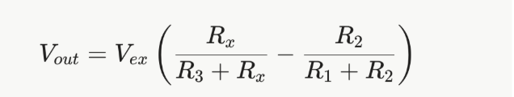
When all four resistors are equal, the output is zero (the bridge is balanced). If the sensor changes by a small fraction x, the output is approximately Vex × x ÷ 4. With Vex = 5 V and x = 0.001, Vout ≈ 1.25 mV, which an instrumentation amplifier (such as the HX711) can then amplify.
1.9 The ADC: Turning Voltage into Numbers
An analog-to-digital converter (ADC) with N bits divides its reference voltage into 2^N steps. One step is:

- Uno: 10-bit, Vref = 5 V, so Q = 5 ÷ 1024 = 4.88 mV. Readings go from 0 to 1023.
- ESP32: 12-bit, about 3.3 V full scale, so Q ≈ 0.81 mV. Readings go from 0 to 4095. The ESP32 ADC is less linear near its ends; use analogReadMilliVolts(), which applies to the factory calibration.
The voltage from a reading is V = reading × Vref ÷ 2^N. A reading of 512 on the Uno means about 2.50 V.
Sampling and aliasing (advanced). The ADC takes samples at a rate fs. To capture a signal correctly, fs must be more than twice the highest frequency in the signal (the Nyquist rule). Faster signals do not disappear; they fold back and appear as false slow signals. This is called aliasing, and it can only be prevented with an analog filter before the ADC.

1.10 The RC Low-Pass Filter
A resistor followed by a capacitor to ground forms a low-pass filter. It lets slow changes through and reduces fast noise. Its cut-off frequency (where the signal falls to 70.7%) is:
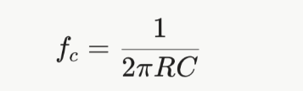
With R = 10 kΩ and C = 100 nF, fc = 159 Hz. Above fc the output falls by 10 times for every 10 times increase in frequency. Choose fc below half the sampling rate. The capacitor also helps the ADC by acting as a small charge reservoir.
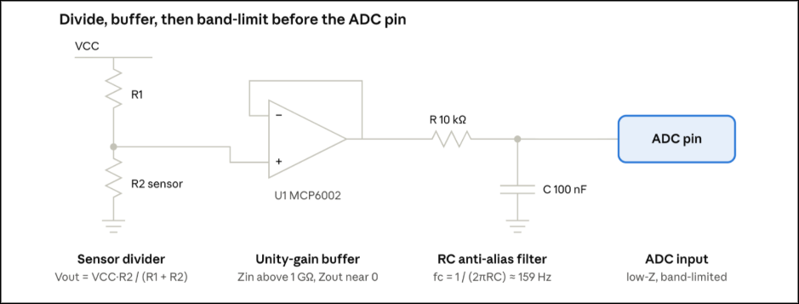Figure 1.2 shows the standard conditioning chain: the sensor divider, a buffer that removes loading error, and an RC filter that removes fast noise before the ADC.
1.11 The Exponential Moving Average (EMA) Filter
After the ADC, some noise is still left. The EMA filter smooths it in software, and is the digital version of the RC filter:
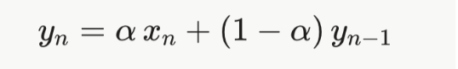
Here x is the new reading, y is the filtered value and α is between 0 and 1. A small α (such as 0.1) gives strong smoothing but a slower response; a large α (such as 0.5) responds faster but smooths less. With a sample period Ts, the EMA behaves like an RC filter with time constant τ = Ts × (1 − α) ÷ α. For Ts = 10 ms and α = 0.1, τ = 90 ms.
The EMA needs only one stored value. For sudden spikes (for example a missed ultrasonic echo), first pass the readings through a median filter of 3 or 5 samples, then through the EMA.
1.12 Uno vs ESP32: Voltage Levels
A 5 V Uno pin reads HIGH above about 3.0 V, so it reads a 3.3 V signal as HIGH. An ESP32 pin must never see more than 3.6 V. A 5 V sensor signal must be reduced before it reaches the ESP32, using:
- A voltage divider (1 kΩ / 2 kΩ) for one-way signals such as a sensor output or a UART TX line.
- A BSS138 MOSFET level shifter for two-way lines such as I2C.
- Or, best of all, powering the sensor at 3.3 V if its datasheet allows it.
On the ESP32, use ADC1 pins (GPIO 32–39) for analog sensors, because ADC2 pins cannot be used while Wi-Fi is on.
1.13 Reading a Sensor Without Blocking
Sensors must be read at a steady rate without freezing the rest of the program. The example below reads an analog sensor every 10 ms with millis() and smooths it with an EMA. It works on both boards.
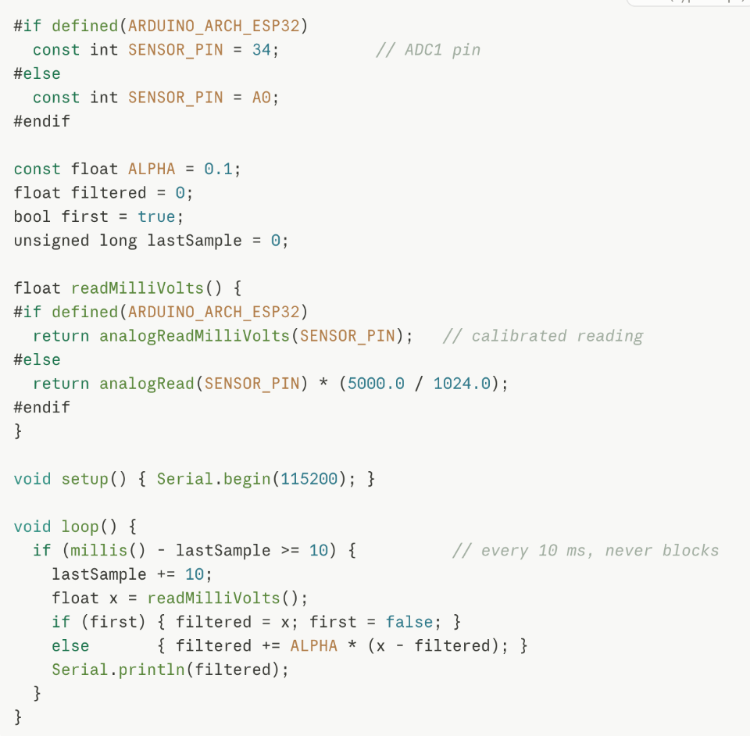
1.14 Common Mistakes to Avoid
- Leaving a digital input floating with no pull-up or pull-down.
- Reading a high-resistance divider (above 10 kΩ) directly with the ADC and getting low values.
- Connecting a 5 V sensor output straight to an ESP32 pin.
- Assuming the Uno's 5 V reference is exactly 5.00 V; USB power often gives 4.8–5.1 V.
- Using delay() between readings, which freezes the whole program.
Practice Questions
- What is the difference between accuracy and precision? Give one example of a sensor that is precise but not accurate.
- A 10 kΩ LDR (R2) is connected below a 10 kΩ resistor (R1) on 5 V. What is the output voltage, and what is the Uno ADC reading?
- Why does an op-amp buffer remove loading error?
- Calculate the cut-off frequency of an RC filter with R = 4.7 kΩ and C = 1 µF.
- An EMA filter samples every 20 ms with α = 0.2. What is its time constant?

2. Distance and Proximity Sensors
2.1 Three Ways to Measure Distance
Most small robots measure distance in one of three ways: by timing a sound echo (ultrasonic), by measuring the angle of reflected infrared light (triangulation), or by timing a laser pulse (laser time of flight). Each one fails in different situations, which is why robots often use more than one.
2.2 Ultrasonic Sensor: HC-SR04
How it works. A piezoelectric disc bends when a voltage is applied and produces a voltage when it is bent. The HC-SR04 sends a burst of eight 40 kHz sound pulses from one disc. The sound bounces off the target and returns to the second disc. The module sets its ECHO pin HIGH for exactly the time the sound took to go out and back.
The math. Because the sound travels to the target and back, the distance is half the total path:
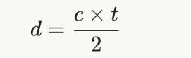
At 20 °C the speed of sound c is 343 m/s, so d (cm) = t (µs) ÷ 58. A 1160 µs echo means 20 cm.
Temperature correction (advanced). The speed of sound changes with air temperature:
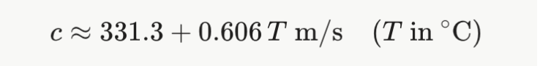
At 0 °C, c = 331.3 m/s, so the "divide by 58" rule gives a reading about 3.5% too high. For a 2 m target that is a 7 cm error.
Limits. Range is 2–400 cm with a beam about 15° wide. Soft materials (cloth, foam) absorb sound, and surfaces tilted more than about 15–20° reflect the echo away. Wait at least 60 ms between measurements so old echoes die out.

2.3 Infrared Triangulation Sensor: Sharp GP2Y0A21YK0F
How it works. An infrared LED sends a narrow beam. The reflected light passes through a lens and lands on a position-sensitive detector (PSD). The closer the target, the further the spot moves along the detector. Because the sensor measures the spot's position, not its brightness, it works on most surface colours.
The output is not linear. The output voltage rises from about 0.4 V at 80 cm to about 3.1 V at 10 cm, following a curve, not a straight line. A power law fits it well:
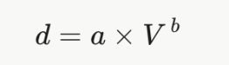
Typical values are a ≈ 27.9 and b ≈ −1.15 (V in volts, d in cm), but each sensor should be calibrated by measuring the voltage at several known distances.
Limits. The useful range is 10–80 cm. Closer than 10 cm the output falls again, so a very close object looks far away. The sensor draws current in short pulses, so place a 10 µF capacitor across its supply pins to stop it adding noise to other analog readings.
2.4 Laser Time-of-Flight Sensor: VL53L0X
How it works. A tiny 940 nm laser (a VCSEL) sends very short light pulses. The receiver is an array of SPADs (single-photon avalanche diodes): diodes biased so strongly that a single photon starts an avalanche of current. Light travels 30 cm per nanosecond, so the chip fires thousands of pulses, records when each photon returns, and builds a histogram. The peak of the histogram gives the distance.
Using it. The VL53L0X reports distance in millimetres over I2C (address 0x29). Its range is about 3–120 cm in default mode and up to about 200 cm in long-range mode. A longer timing budget (the time spent measuring, for example 33 ms or 200 ms) gives less noisy readings but fewer readings per second.

2.5 Comparing the Three Sensors
Property | HC-SR04 ultrasonic | Sharp GP2Y0A21 IR | VL53L0X laser ToF
Principle | Sound echo timing | Infrared triangulation | Laser pulse timing
Range | 2–400 cm | 10–80 cm | 3–120 cm (up to 200 cm)
Output | Pulse width on ECHO | Analog voltage, non-linear | Millimetres over I2C
Resolution | About 0.3 cm | 0.05–1 cm, worse when far | 1 mm
Update rate | About 16 Hz | About 26 Hz | 5–50 Hz
Beam width | About 15° | A few degrees | About 25°
Weak against | Soft or angled surfaces | Objects under 10 cm, sunlight | Bright sunlight, glass
2.6 Connecting to the Uno and the ESP32
- HC-SR04: VCC to 5 V. TRIG to Uno D7 or ESP32 GPIO 5. ECHO to Uno D2 directly, but to the ESP32 (GPIO 18) only through a 1 kΩ / 2 kΩ divider, because ECHO is a 5 V signal.
- Sharp sensor: 5 V supply with a 10 µF capacitor. Output to Uno A2 or ESP32 GPIO 33. The output stays below about 3.1 V, so it is safe for the ESP32.
- VL53L0X: use a breakout board with a regulator. VIN to 5 V (Uno) or 3.3 V (ESP32). SDA/SCL to Uno A4/A5 or ESP32 GPIO 21/22.
2.7 Measuring the Echo Without Blocking
pulseIn() waits for the whole echo, up to 38 ms when there is no target, and freezes the program. A better method uses an interrupt on the ECHO pin: the rising edge saves the time, the falling edge calculates the width. The main loop just checks a flag.
#if defined(ARDUINO_ARCH_ESP32)
#define ISR_ATTR IRAM_ATTR
const int TRIG = 5, ECHO = 18; // ECHO through 1k/2k divider
#else
#define ISR_ATTR
const int TRIG = 7, ECHO = 2; // D2 = interrupt pin
#endif
volatile unsigned long riseUs = 0, widthUs = 0;
volatile bool echoReady = false;
void ISR_ATTR onEcho() {
unsigned long now = micros();
if (digitalRead(ECHO) == HIGH) riseUs = now;
else { widthUs = now - riseUs; echoReady = true; }
}
unsigned long lastTrig = 0;
void setup() {
Serial.begin(115200);
pinMode(TRIG, OUTPUT);
pinMode(ECHO, INPUT);
attachInterrupt(digitalPinToInterrupt(ECHO), onEcho, CHANGE);
}
void loop() {
if (millis() - lastTrig >= 60) { // one measurement every 60 ms
lastTrig = millis();
digitalWrite(TRIG, HIGH); delayMicroseconds(10); digitalWrite(TRIG, LOW);
}
if (echoReady) {
noInterrupts(); // safe copy of shared data
unsigned long w = widthUs;
echoReady = false;
interrupts();
float cm = w / 58.0;
if (cm >= 2 && cm <= 400) Serial.println(cm);
}
}
The noInterrupts() / interrupts() pair matters on the 8-bit Uno: a 32-bit variable is read one byte at a time, and an interrupt in the middle would give a mixed-up value.
2.8 Common Mistakes to Avoid
- Connecting the HC-SR04 ECHO pin straight to an ESP32 pin.
- Using pulseIn() with no timeout, which can freeze the robot for up to a second.
- Triggering two ultrasonic sensors at the same time, so each hears the other.
- Trusting a Sharp reading without checking that the object is further than 10 cm.
- Calling a VL53L0X "single read" function that waits for the whole timing budget.
Practice Questions
- An HC-SR04 echo lasts 2900 µs at 20 °C. How far away is the target?
- Why does the Sharp sensor work on both white and grey targets, while a simple IR reflectance sensor does not?
- Recalculate question 1 for an air temperature of 35 °C. How large is the difference?
- Why does the VL53L0X fire thousands of pulses instead of timing just one?
- Which sensor would you choose to detect the edge of a table, and why?

3. Environmental Sensors
3.1 Measuring Humidity: The Capacitive Sensor
The humidity element inside the DHT22 is a small capacitor whose insulating layer is a polymer that absorbs water from the air. Water stores electric charge far better than the dry polymer (its relative permittivity is about 80, compared with 3–5). As humidity rises, the polymer absorbs more water and the capacitance rises:
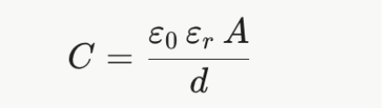
Here ε0 is a constant, εr is the relative permittivity of the layer, A is the plate area and d is the gap.
3.2 Measuring Temperature: The Thermistor
Temperature is measured with an NTC thermistor, a ceramic whose resistance falls as it gets warmer (NTC means negative temperature coefficient). A small chip inside the DHT22 measures both the capacitor and the thermistor, applies factory calibration, and sends finished values. Typical accuracy is ±2% RH and ±0.5 °C.
3.3 The DHT22 Single-Wire Protocol
The DHT22 uses one data wire with a pull-up resistor (4.7–10 kΩ). A reading works like this:
- The microcontroller pulls the line LOW for at least 1 ms, then releases it.
- The sensor answers with 80 µs LOW and 80 µs HIGH.
- The sensor sends 40 bits. Each bit starts with 50 µs LOW; a HIGH of about 27 µs means 0, and about 70 µs means 1.
- The 40 bits form 5 bytes: humidity (2 bytes), temperature (2 bytes) and a checksum.
Humidity and temperature are sent as whole numbers ten times larger than the real value. The checksum is the lowest byte of the sum of the first four bytes, so a corrupted reading can be detected.
Example. The bytes 0x02 0x8C 0x01 0x5F 0xEE give humidity 0x028C = 652 → 65.2% and temperature 0x015F = 351 → 35.1 °C. The checksum 0x02 + 0x8C + 0x01 + 0x5F = 0xEE matches, so the reading is valid.
The DHT22 can only be read once every 2 seconds. A full reading takes about 5 ms.
3.4 Dew Point (Advanced)
The dew point is the temperature at which the air becomes saturated and water starts to condense. It tells a robot designer when moisture will form on cold surfaces or electronics. The Magnus formula calculates it from temperature T (°C) and relative humidity RH (%):
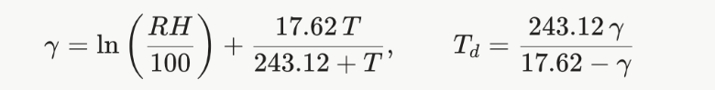
Example: T = 25 °C, RH = 60%. γ = ln(0.60) + (17.62 × 25) ÷ 268.12 = −0.511 + 1.643 = 1.132. Td = (243.12 × 1.132) ÷ (17.62 − 1.132) = 16.7 °C. Any surface colder than 16.7 °C in that room will get wet.
3.5 Gas Sensing: The MQ-2
How it works. The MQ-2 contains a layer of tin dioxide (SnO2) heated to about 300 °C by a small coil. In clean air, oxygen sticks to the surface of the SnO2 grains and traps free electrons, which creates a barrier between grains and makes the resistance high. When a combustible gas such as LPG, hydrogen, methane or smoke arrives, it reacts with that oxygen and releases the electrons back. The barrier gets lower and the resistance falls sharply.
The heater is essential: it gives the surface reactions enough energy and keeps water off the surface. The MQ-2 reacts to many gases, so it is a gas detector, not a precise gas analyser.
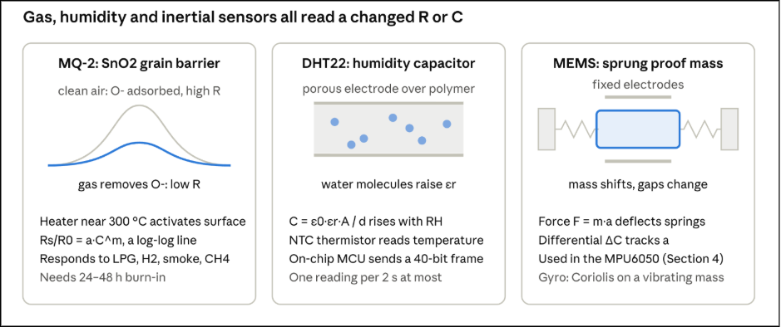All three sensors in Figure 3.1 share one idea: the environment changes a resistance or a capacitance, and a circuit measures that change. The MEMS sensor on the right is covered in Section 4.
3.6 Reading the MQ-2
The sensor resistance Rs sits in series with a load resistor RL (1 kΩ on most modules) across 5 V. The module outputs the voltage across RL, from which Rs can be found:
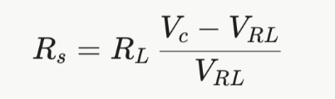
The datasheet describes the sensor using the ratio Rs/R0, where R0 is a reference resistance. In clean air, Rs/R0 is about 9.8, so R0 can be estimated as Rs (clean air) ÷ 9.8. As gas increases, Rs/R0 falls.
Estimating concentration (advanced). On the datasheet's log-log chart, each gas forms a nearly straight line, which means a power law: Rs/R0 = a × C^m. Reading two points from the chart gives m and a, and the gas level can then be estimated from the measured ratio. Treat the result as an approximate indication, not an exact ppm value.

Practical notes.
- A new MQ-2 needs 24–48 hours of heater power (burn-in) before its readings settle, and a 2–3 minute warm-up after each power-on.
- The heater draws about 150 mA at 5 V. Give it its own ground wire to the supply to avoid noise on other analog readings.
- For an alarm, use two thresholds (hysteresis): for example, turn on when Rs/R0 falls below 3.0 and turn off only when it rises above 4.0. This stops the alarm from flickering.
3.7 Connecting to the Uno and the ESP32
- DHT22: on the Uno, power at 5 V with the pull-up to 5 V. On the ESP32, power at 3.3 V with the pull-up to 3.3 V, so the data line never reaches 5 V.
- MQ-2: the heater always needs 5 V. The analog output can reach 5 V, so on the ESP32 it must pass through a 10 kΩ / 20 kΩ divider before GPIO 36 or 39 (remember to multiply the reading by 1.5). The digital output (DO) is also a 5 V signal.
- Timing note: most DHT libraries switch interrupts off for about 5 ms on the Uno while reading. During that time the Uno can miss fast signals such as encoder pulses.

3.8 Reading the DHT22 Without Blocking
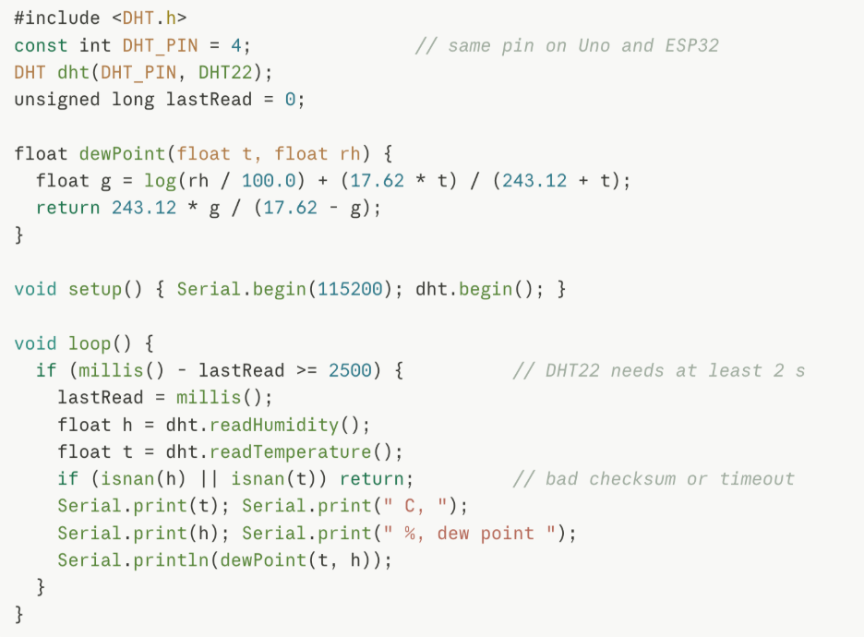
3.9 Common Mistakes to Avoid
- Reading the DHT22 more often than every 2 seconds.
- Forgetting the pull-up resistor on the DHT22 data line.
- Placing the DHT22 next to a regulator or the MQ-2 heater, so it reads too warm.
- Calibrating the MQ-2 before burn-in, or in air that is not clean.
- Connecting the MQ-2 analog output directly to an ESP32 pin.

Practice Questions
- Why does the capacitance of a humidity sensor increase when humidity rises?
- Decode the DHT22 bytes 0x01 0xF4 0x00 0xFA 0xEF. Is the checksum correct?
- Calculate the dew point for T = 30 °C and RH = 50%.
- An MQ-2 module with RL = 1 kΩ outputs 1.0 V on a 5 V supply. What is Rs?
- Why does the MQ-2 need a heater, and why should an alarm use two thresholds?

4. Motion and Kinematic Sensors
4.1 PIR Motion Sensors
How it works. A PIR (passive infrared) sensor detects the heat given off by people and animals. Its core is a pyroelectric crystal, a material that produces a small electric charge when its temperature changes. It does not respond to a steady temperature, only to change.
The sensor has two crystal elements wired in opposite directions. Slow changes, such as a room warming up, affect both equally and cancel out. A person walking past warms one element before the other, giving a clear signal.
A Fresnel lens (the white dome) is made of many small lens segments. It divides the room into zones, so a moving person crosses from zone to zone and produces a series of pulses. This is why a PIR detects movement, not a person who stands perfectly still.
The HC-SR501 module gives a 3.3 V HIGH output when it detects motion, so it is safe for both the Uno and the ESP32 with no level shifting. It has two adjustment knobs: sensitivity (range up to about 7 m) and how long the output stays HIGH (about 3 s to 5 minutes). It needs about 30–60 seconds to settle after power-on.
4.2 The MPU6050 IMU
An IMU (inertial measurement unit) measures motion. The MPU6050 contains a 3-axis accelerometer and a 3-axis gyroscope, giving 6 degrees of freedom (6-DoF). It is a MEMS device (micro-electro-mechanical system): tiny mechanical parts built on a silicon chip.
- Accelerometer: a tiny mass held by springs. When the chip accelerates, the mass moves and changes the gap between fixed plates, which changes capacitance (see Figure 3.1). Gravity also pulls on the mass, so at rest the accelerometer measures 1 g pointing downward.
- Gyroscope: a vibrating mass. When the chip rotates, the Coriolis effect pushes the mass sideways, and that movement is measured. The gyroscope measures rotation rate in degrees per second (°/s), not an angle.
The MPU6050 talks over I2C (address 0x68). With the default settings, the raw readings are converted like this:
- Acceleration (g) = raw ÷ 16384 (range ±2 g)
- Rotation rate (°/s) = raw ÷ 131 (range ±250 °/s)
4.3 Tilt from the Accelerometer
When the sensor is still, the accelerometer measures only gravity. The direction of gravity tells us the tilt. Using the three readings ax, ay and az:
atan2 is used instead of plain atan because it gives the correct angle in all four quadrants. Example: ax = 0, ay = 0.5 g, az = 0.866 g gives roll = atan2(0.5, 0.866) = 30°.
The weakness: when the robot moves, shakes or vibrates, those accelerations are added to gravity, so the tilt reading becomes noisy.
4.4 Angle from the Gyroscope and Drift
The gyroscope measures rotation rate ω. To get an angle, add up (integrate) the rate over time:
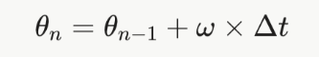
This is smooth and not affected by vibration. Its weakness is drift: every gyroscope has a small error called bias. When the bias is integrated, the error grows steadily. A bias of only 0.5 °/s becomes a 30° error after one minute. Measuring the average gyro reading while the robot is still at start-up, and subtracting it, reduces (but does not remove) the drift.
4.5 The Complementary Filter (Advanced)
The two sensors have opposite strengths:
- The accelerometer is correct over long times but noisy over short times.
- The gyroscope is smooth over short times but drifts over long times.
The complementary filter combines them: it trusts the gyroscope for fast changes and the accelerometer for the long-term average.
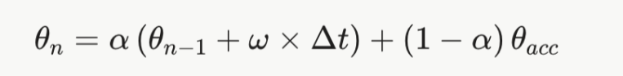
Where it comes from. The gyro angle is passed through a high-pass filter (which removes slow drift) and the accelerometer angle through a low-pass filter (which removes fast noise). Both filters use the same time constant τ, so together they pass every frequency exactly once. In discrete form, the weight is:
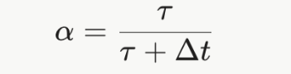
Example: with τ = 0.5 s and a 100 Hz loop (Δt = 0.01 s), α = 0.5 ÷ 0.51 = 0.98. Each step uses 98% of the gyro-updated angle and 2% of the accelerometer angle. A larger τ trusts the gyro more (smoother, but slower to correct drift); a smaller τ trusts the accelerometer more (faster correction, but noisier).
The complementary filter is simple enough to run on the Uno. More advanced robots use a Kalman filter, which adjusts the weighting automatically from noise estimates.
4.6 Connecting to the Uno and the ESP32
- MPU6050 (GY-521 board): VCC to 5 V (Uno) or 3.3 V (ESP32); the board has its own 3.3 V regulator and I2C pull-ups. SDA/SCL to Uno A4/A5 or ESP32 GPIO 21/22.
- PIR (HC-SR501): VCC to 5 V; OUT to any digital pin (Uno D8, ESP32 GPIO 27).
- Speed: atan2 and sqrt take 100–200 µs on the Uno, which has no floating-point hardware, and only a few microseconds on the ESP32. Keep them out of interrupt routines.
4.7 Code: Tilt with a Complementary Filter
#include <Wire.h>
const int MPU = 0x68;
const float ALPHA = 0.98;
float roll = 0, gyroBias = 0;
unsigned long lastUs = 0;
void readMPU(int16_t &ax, int16_t &ay, int16_t &az, int16_t &gx) {
Wire.beginTransmission(MPU);
Wire.write(0x3B); // first data register
Wire.endTransmission(false);
Wire.requestFrom(MPU, 14);
ax = Wire.read() << 8 | Wire.read();
ay = Wire.read() << 8 | Wire.read();
az = Wire.read() << 8 | Wire.read();
Wire.read(); Wire.read(); // skip temperature
gx = Wire.read() << 8 | Wire.read();
Wire.read(); Wire.read(); Wire.read(); Wire.read(); // skip gy, gz
}
void setup() {
Serial.begin(115200);
#if defined(ARDUINO_ARCH_ESP32)
Wire.begin(21, 22);
#else
Wire.begin();
#endif
Wire.beginTransmission(MPU);
Wire.write(0x6B); Wire.write(0); // wake the sensor
Wire.endTransmission();
int16_t ax, ay, az, gx;
long sum = 0;
for (int i = 0; i < 200; i++) { readMPU(ax, ay, az, gx); sum += gx; }
gyroBias = sum / 200.0 / 131.0; // keep still during start-up
lastUs = micros();
}
void loop() {
if (micros() - lastUs < 10000) return; // run at 100 Hz
unsigned long now = micros();
float dt = (now - lastUs) / 1e6;
lastUs = now;
int16_t ax, ay, az, gx;
readMPU(ax, ay, az, gx);
float accRoll = atan2((float)ay, (float)az) * 57.296; // radians to degrees
float rate = gx / 131.0 - gyroBias; // degrees per second
roll = ALPHA * (roll + rate * dt) + (1 - ALPHA) * accRoll;
Serial.println(roll);
}
4.8 Common Mistakes to Avoid
- Forgetting to wake the MPU6050 (register 0x6B), so every reading is zero.
- Using atan instead of atan2, which gives wrong angles past ±90°.
- Using a fixed Δt instead of measuring the real time between loops.
- Moving the sensor during gyro bias calibration.
- Expecting a PIR to detect a person who is not moving.
Practice Questions
- Why does a PIR sensor use two opposite pyroelectric elements?
- An MPU6050 reads ax = 0, ay = 8192, az = 14189 (raw). Find the roll angle.
- A gyroscope has a bias of 0.2 °/s. How large is the angle error after 5 minutes of integration?
- Calculate α for a complementary filter with τ = 1 s running at 200 Hz.
- Explain in your own words why the complementary filter is better than using either sensor alone.

5. Light and Optical Sensors
5.1 Light as Energy
Light arrives in small packets of energy called photons. A photon's energy is E = h × c ÷ λ, where λ is the wavelength: blue light (450 nm) carries more energy per photon than red light (650 nm). When a photon with enough energy hits a semiconductor, it frees an electron and creates an electron-hole pair. Every light sensor in this section works by collecting these freed charges.
5.2 The LDR (Light-Dependent Resistor)
How it works. An LDR is made of cadmium sulphide (CdS). In the dark it has very few free electrons and a high resistance (about 1 MΩ). Light frees electrons, and the resistance falls (about 10–20 kΩ at 10 lux for the GL5528). This effect is called photoconductivity.
The curve. The resistance follows a power law with light level L (in lux):
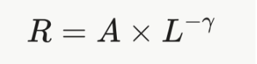
γ is usually between 0.7 and 0.9. On a log-log graph this is a straight line. Because of this, an LDR is good for "dark or bright" decisions, but not for precise light measurement.
Reading it. Place the LDR in a voltage divider (Section 1.6). With the LDR as R1 and a fixed 10 kΩ as R2, the output voltage rises as the light gets brighter. Choose the fixed resistor close to the LDR's resistance at the light level you care about most, because the divider is most sensitive there.
Limits. LDRs are slow (tens of milliseconds to respond, longer to recover from bright light), vary between units, and change with temperature.
5.3 The Photodiode
How it works. A photodiode is a PN junction with a window. Photons absorbed near the junction create electron-hole pairs, and the junction's electric field sweeps them apart, producing a photocurrent proportional to the light power:

Rλ is the responsivity (about 0.6 A/W for a silicon photodiode near 900 nm). The current is tiny, often a few microamps or less.
Two ways to use it.
- Photovoltaic mode (no bias voltage): very low noise, but slower. Used in light meters.
- Photoconductive mode (reverse-biased): a wider depletion layer means less capacitance and a much faster response (nanoseconds). Used in fast receivers.
The transimpedance amplifier (advanced). To turn the small current into a voltage, an op-amp is connected with a feedback resistor Rf. The op-amp holds the photodiode at 0 V and all the photocurrent flows through Rf:
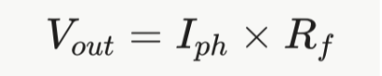
With Iph = 2 µA and Rf = 1 MΩ, Vout = 2 V. Photodiodes are very linear, so this gives an accurate light measurement.
5.4 The Phototransistor
A phototransistor is a transistor whose base is exposed to light. The photocurrent acts as the base current, and the transistor amplifies it by its current gain β (often 100–1000). It is therefore much more sensitive than a photodiode and can be read with just a resistor. The cost is speed (microseconds instead of nanoseconds) and linearity.
Choosing between them:
- LDR: cheap, simple, slow; good for day/night detection.
- Photodiode: linear, fast, needs an amplifier; good for precise measurement and fast signals.
- Phototransistor: sensitive, simple, moderately fast; good for line followers, break-beams and encoders.

5.5 The TCS3200 Colour Sensor
How it works. The TCS3200 has an 8 × 8 array of photodiodes: 16 with red filters, 16 with green, 16 with blue and 16 with no filter (clear). A built-in current-to-frequency converter turns the photocurrent into a square wave. More light gives a higher frequency, so the output is easy to read with a digital pin, with no ADC needed.
Control pins.
- S2, S3 choose which photodiodes are active: LOW/LOW = red, HIGH/HIGH = green, LOW/HIGH = blue, HIGH/LOW = clear.
- S0, S1 set the frequency scaling: 2%, 20% or 100% of the full output (full scale is about 500–600 kHz).
Calibration. The raw frequency depends on the light source and distance, so the sensor is calibrated with a white and a black reference card. Each colour reading is then scaled to 0–255:
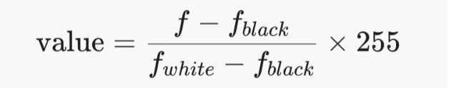
The colour is decided by comparing the scaled red, green and blue values, for example by finding the nearest stored reference colour.
5.6 Connecting to the Uno and the ESP32
- LDR divider: output to Uno A1 or ESP32 GPIO 32. Power the divider from the same supply the ADC uses (5 V on the Uno, 3.3 V on the ESP32).
- TCS3200: power at 5 V on the Uno, or at 3.3 V on the ESP32 so the output never exceeds 3.3 V. OUT goes to an interrupt pin (Uno D3, ESP32 GPIO 19).
- Frequency scaling: use 20% on the ESP32. On the Uno use 2%, because each interrupt takes a few microseconds and a 100 kHz signal would take most of the Uno's time.
5.7 Code: Measuring TCS3200 Frequency Without Blocking
The code counts output edges with an interrupt for a fixed 50 ms window, then moves to the next colour filter.
#if defined(ARDUINO_ARCH_ESP32)
#define ISR_ATTR IRAM_ATTR
const int S2 = 25, S3 = 26, OUT = 19;
#else
#define ISR_ATTR
const int S2 = 6, S3 = 7, OUT = 3; // D3 = interrupt pin
#endif
volatile unsigned long edges = 0;
void ISR_ATTR onEdge() { edges++; }
const char* NAMES[3] = {"R", "G", "B"};
const bool S2_SET[3] = {LOW, HIGH, LOW}; // red, green, blue
const bool S3_SET[3] = {LOW, HIGH, HIGH};
int filter = 0;
unsigned long windowStart = 0;
void selectFilter(int f) {
digitalWrite(S2, S2_SET[f]);
digitalWrite(S3, S3_SET[f]);
noInterrupts(); edges = 0; interrupts();
windowStart = millis();
}
void setup() {
Serial.begin(115200);
pinMode(S2, OUTPUT); pinMode(S3, OUTPUT); pinMode(OUT, INPUT);
attachInterrupt(digitalPinToInterrupt(OUT), onEdge, RISING);
selectFilter(0);
}
void loop() {
if (millis() - windowStart >= 50) { // 50 ms counting window
noInterrupts();
unsigned long n = edges; // atomic copy
interrupts();
float hz = n / 0.050;
Serial.print(NAMES[filter]); Serial.print("="); Serial.print(hz);
Serial.print(filter == 2 ? "\n" : " ");
filter = (filter + 1) % 3;
selectFilter(filter);
}
}
S0 and S1 are wired to fixed levels for the chosen scaling (for 20%: S0 HIGH, S1 LOW; for 2%: S0 LOW, S1 HIGH).
5.8 Common Mistakes to Avoid
- Expecting an LDR to give an accurate lux value without calibration.
- Reading a photodiode with only a resistor and getting a very small, noisy voltage.
- Letting room light reach the TCS3200; shield it with a short black tube.
- Running the TCS3200 at 100% scaling on the Uno, so interrupts swamp the CPU.
- Skipping the white and black calibration after changing the lighting.
Practice Questions
- Why does an LDR's resistance fall as light increases?
- An LDR reads 15 kΩ and sits as R1 above a 10 kΩ resistor on 5 V. What voltage does the Uno read, and what is the ADC value?
- A photodiode gives 0.5 µA. What feedback resistor gives a 2.5 V output from a transimpedance amplifier?
- Give one advantage and one disadvantage of a phototransistor compared with a photodiode.
- A TCS3200 red channel reads 9 kHz. The white reference is 12 kHz and the black reference is 1 kHz. What is the scaled red value?

6. Position and Displacement Sensors
6.1 The Potentiometer
How it works. A potentiometer is a resistive track with a sliding contact called the wiper. The two ends of the track connect to the supply and ground, so the potentiometer is a voltage divider whose ratio changes with position. The output voltage is proportional to the shaft angle:
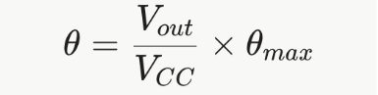
A typical rotary potentiometer turns about 270°. On the Uno, a reading of 512 means about 135°.
Strengths and limits. A potentiometer gives absolute position: it knows its angle as soon as power is applied. Because the reading is a ratio, small supply changes cancel out (this is called a ratiometric measurement). However, the wiper wears over time, gets noisy, and cannot turn continuously. Servo motors use a potentiometer inside to know their angle.
6.2 Incremental Encoders
How it works. An optical incremental encoder has a disc with evenly spaced slots. An LED shines through the slots onto a phototransistor (Section 5.4). As the shaft turns, the light is broken and restored, producing a square wave. Magnetic encoders do the same with a magnet and a Hall-effect sensor.
The encoder does not know its absolute position. It only reports changes, so the microcontroller must count every pulse from a known starting point.
PPR and CPR. PPR (pulses per revolution) is the number of slots on the disc. Encoders have two channels, A and B, so each slot produces four edges. Counting all four edges is called x4 decoding:
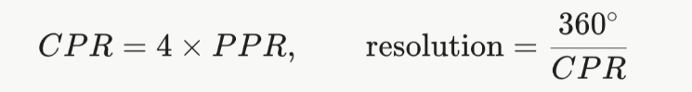
A 600 PPR encoder gives 2400 counts per revolution, a resolution of 0.15°.
6.3 Quadrature: Finding the Direction
The two channels are placed so that their signals are 90° apart (one quarter of a cycle). This is called quadrature. When the shaft turns forward, A changes before B; in reverse, B changes before A.
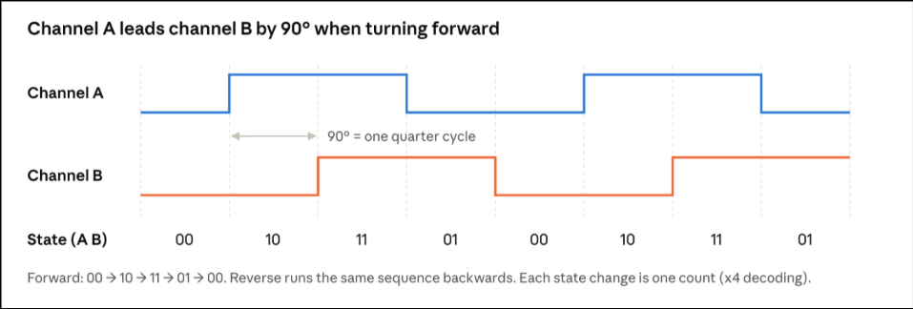
Together, A and B form a 2-bit state that changes in a fixed order. Moving forward, the states go 00 → 10 → 11 → 01 → 00. Moving in reverse, the order is opposite. By comparing the previous state with the new state, the program knows both that the shaft moved and in which direction.
A simple way to decode this is a lookup table. The previous state and the new state together form a 4-bit index (0–15), and the table gives +1, −1 or 0 for each possible change. Invalid jumps (such as 00 to 11, which skips a state) give 0, so a noisy glitch does not create a false count.
6.4 Speed and RPM
To find speed, count how many counts arrive in a fixed time window Δt:
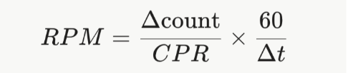
Example: 400 counts in 0.1 s with CPR = 2400 → 400 ÷ 2400 = 0.167 revolutions in 0.1 s → 100 RPM.
This count-per-window method is accurate at high speed. At very low speed only a few counts arrive in each window, so the result jumps in steps. For low speed, a better method is to measure the time between edges with micros() and calculate speed from that period.
6.5 Interrupts and Safe Shared Data (Advanced)
Encoder pulses can be very fast. A 600 PPR encoder at 1000 RPM produces 2400 × 1000 ÷ 60 = 40,000 edges per second, one every 25 µs. Polling in loop() would miss most of them, so each edge triggers an interrupt service routine (ISR).
Three rules keep the count correct:
- The count variable is declared volatile, so the compiler always reads its latest value from memory instead of a stale copy.
- The ISR is kept short: read the pins, update the count, nothing else. No Serial, no delay(), no floating-point math.
- The main loop reads the count inside noInterrupts() / interrupts(). On the 8-bit Uno, a 32-bit long is read one byte at a time; if an interrupt changes it halfway, the copy would be a mix of old and new bytes and could be wildly wrong. This is called an atomic read.
6.6 Connecting to the Uno and the ESP32
- Uno: only D2 and D3 have external interrupts, so channel A goes to D2 and channel B to D3. At high speeds, digitalRead() inside the ISR is slow (about 4 µs); faster code reads the port register directly.
- ESP32: any GPIO can trigger an interrupt (for example GPIO 34 and 35). Mark the ISR with IRAM_ATTR. For very fast encoders, the ESP32 also has a hardware pulse counter (PCNT) that counts quadrature edges with no CPU load.
- Pull-ups: many encoders have open-collector outputs. Add a pull-up to the board's logic voltage: 2.2 kΩ to 3.3 V on the ESP32 (GPIO 34–39 have no internal pull-ups), or 2.2–4.7 kΩ to 5 V on the Uno.
6.7 Code: Position and RPM with Interrupts
#if defined(ARDUINO_ARCH_ESP32)
#define ISR_ATTR IRAM_ATTR
const int PIN_A = 34, PIN_B = 35; // external 2.2k pull-ups to 3.3 V
#else
#define ISR_ATTR
const int PIN_A = 2, PIN_B = 3; // the Uno's two interrupt pins
#endif
const long CPR = 2400; // 600 PPR x 4
// +1 forward, -1 reverse, 0 no change or invalid jump
const int8_t TABLE[16] = {0,-1,+1,0, +1,0,0,-1, -1,0,0,+1, 0,+1,-1,0};
volatile long count = 0;
volatile uint8_t prevState = 0;
void ISR_ATTR onEdge() {
uint8_t state = (digitalRead(PIN_A) << 1) | digitalRead(PIN_B);
count += TABLE[(prevState << 2) | state];
prevState = state;
}
long lastCount = 0;
unsigned long lastMs = 0;
void setup() {
Serial.begin(115200);
pinMode(PIN_A, INPUT); pinMode(PIN_B, INPUT);
prevState = (digitalRead(PIN_A) << 1) | digitalRead(PIN_B);
attachInterrupt(digitalPinToInterrupt(PIN_A), onEdge, CHANGE);
attachInterrupt(digitalPinToInterrupt(PIN_B), onEdge, CHANGE);
}
void loop() {
if (millis() - lastMs >= 100) { // 100 ms speed window
lastMs += 100;
noInterrupts();
long c = count; // atomic copy
interrupts();
long delta = c - lastCount;
lastCount = c;
float rpm = (float)delta / CPR * 600.0; // 60 s / 0.1 s = 600
float angle = (float)(c % CPR) * 360.0 / CPR;
Serial.print("count "); Serial.print(c);
Serial.print(" angle "); Serial.print(angle);
Serial.print(" rpm "); Serial.println(rpm);
}
}
6.8 Common Mistakes to Avoid
- Forgetting pull-ups on open-collector encoder outputs, so the inputs float.
- Using a non-interrupt pin on the Uno for an encoder channel.
- Reading a multi-byte volatile count without noInterrupts() on the Uno.
- Doing printing or floating-point math inside the ISR.
- Using the count-per-window method at very low speeds and getting jumpy RPM values.
Practice Questions
- What is the difference between an absolute sensor (potentiometer) and an incremental sensor (encoder)?
- A 360 PPR encoder is read with x4 decoding. What are its CPR and its resolution in degrees?
- The state changes from 11 to 01. Using the forward sequence in Figure 6.1, which way is the shaft turning?
- A 2400 CPR encoder gives 1200 counts in 50 ms. Calculate the RPM.
- Why must the encoder count be read inside noInterrupts() on the Uno but is less critical on the ESP32?

7. System Integration: RoboSense
7.1 The Idea
RoboSense brings the sensors of this module together into one sensing hub for a small mobile robot. It uses two boards, each doing the job it is best at:
- The Arduino Uno field node reads the slow, 5 V sensors: the ultrasonic ranger, the DHT22, the MQ-2, the PIR and the LDR. It packs the readings into one message and sends it five times per second.
- The ESP32 controller reads the fast and mathematically heavy sensors: the MPU6050 (with the complementary filter), the VL53L0X and the wheel encoder. It receives the Uno's messages, combines everything, and decides what the robot should do.
The two boards share nothing except messages on a serial link, so each board can be built and tested on its own.
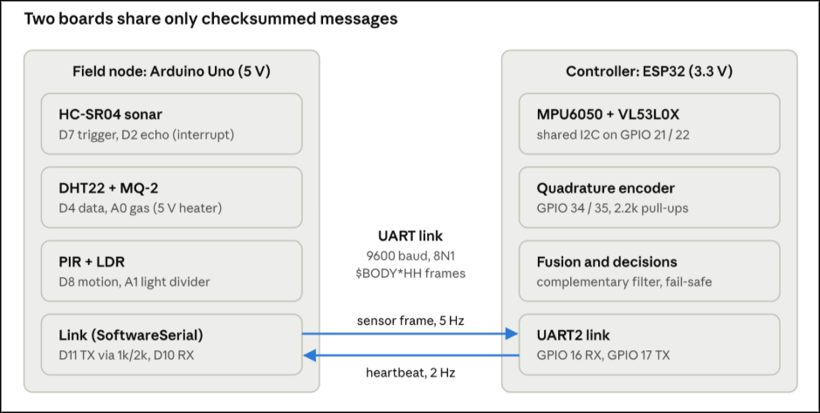
7.2 Why Split the Work This Way
Each choice in Figure 7.1 follows from earlier sections:
- The DHT22 library switches interrupt off for about 5 ms on the Uno (Section 3.7). Encoder pulses arriving in that time would be lost, so the encoder is on the ESP32, never on the same board as the DHT22.
- The complementary filter uses atan2 and floating-point math at 100 Hz (Section 4.5). The ESP32's floating-point unit does this in microseconds; the Uno would spend a large part of its time on it.
- The MQ-2 heater, HC-SR04 and Sharp-style analog sensors are 5 V parts. Keeping them on the Uno avoids level shifting on every line; only the link crosses between 5 V and 3.3 V.
7.3 The Message Format
RoboSense uses a text format inspired by NMEA, the format GPS modules use:
$BODY*HH
- $ marks the start of a message, so a receiver that joins mid-stream knows where to begin.
- BODY is a list of comma-separated fields.
- * marks the end of the body, followed by HH, the checksum written as two hexadecimal digits.
- Each message ends with a newline.
The checksum is the XOR of every character between $ and *. XOR compares bits: two equal bits give 0, two different bits give 1. Example: for $HB*HH, the body is "HB". 'H' = 0x48 and 'B' = 0x42; 0x48 XOR 0x42 = 0x0A, so the full message is $HB*0A. If any bit is flipped on the wire, the receiver's checksum will not match and the message is thrown away.
The XOR checksum catches any single-bit error, but it can miss two errors that cancel out. Industrial links use a stronger CRC (cyclic redundancy check) for that reason.
The messages:
- Uno → ESP32, every 200 ms: $RSF,seq,dist_mm,temp10,rh10,gas100,pir,light*HH. For example, a temperature of 25.1 °C is sent as 251. Sending whole numbers avoids floating-point formatting, which snprintf does not support on the Uno.
- ESP32 → Uno, every 500 ms: $HB*0A, a heartbeat that tells the Uno the controller is alive.
The sequence number seq increases by one in every frame, so the ESP32 can detect lost messages.
7.4 Link Timing (Advanced)
At 9600 baud with 8N1 format, each character takes 10 bits (start bit, 8 data bits, stop bit), so one character takes about 1.04 ms. A 50-character frame takes about 52 ms. Sending one every 200 ms uses about 26% of the link's capacity, which leaves room for retries and future fields. The Uno sends with SoftwareSerial, because its only hardware UART is used by USB.
7.5 Fail-safe Design
A robot must stay safe when something breaks. RoboSense uses a watchdog on the link:
- The ESP32 records the time of every valid frame. If no valid frame arrives for 1 second (five missed frames), it declares the link lost and stops the robot's motors.
- The Uno does the same with the heartbeat. If it hears nothing for 2 seconds, it switches on a warning buzzer.
- Invalid sensor readings are sent as a fixed error value (for example a distance of 0), never as a believable number, so the controller cannot mistake "no reading" for "far away".
7.6 Master Pin Map
Board | Function | Pin
Uno | HC-SR04 trigger / echo | D7 / D2
Uno | DHT22 data (10 kΩ pull-up) | D4
Uno | MQ-2 analog output | A0
Uno | LDR divider output | A1
Uno | PIR output | D8
Uno | Warning buzzer | D6
Uno | Link RX ← ESP32 TX (3.3 V, direct) | D10
Uno | Link TX → 1 kΩ / 2 kΩ divider → ESP32 RX | D11
ESP32 | UART2 RX / TX | GPIO 16 / 17
ESP32 | I2C SDA / SCL (MPU6050, VL53L0X) | GPIO 21 / 22
ESP32 | Encoder A / B (2.2 kΩ pull-ups to 3.3 V) | GPIO 34 / 35
ESP32 | Status LED | GPIO 2
Both | Common ground | GND
7.7 Code: Building and Checking a Frame
The same helper functions are used on both boards:
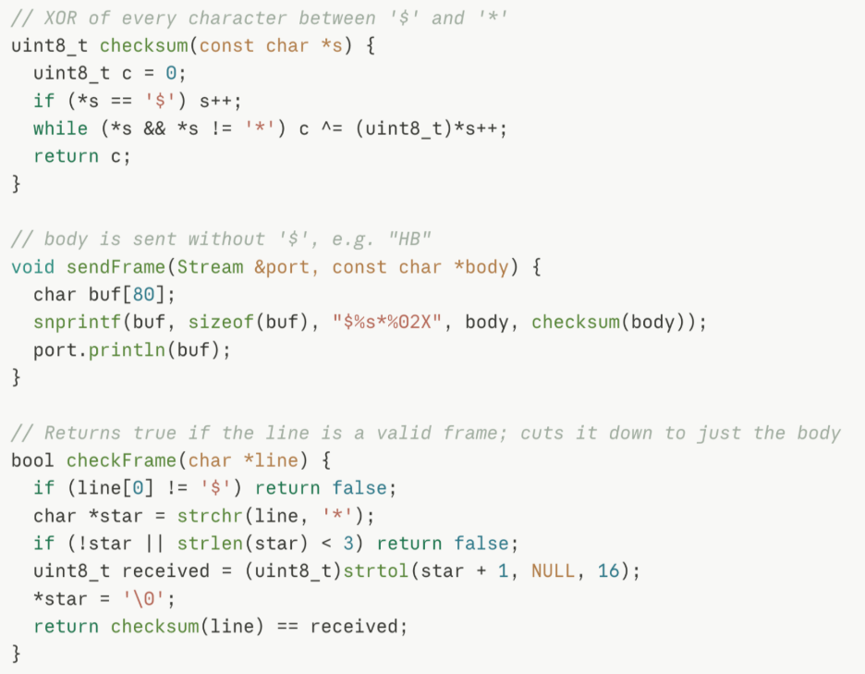
On the Uno, a sensor frame is built from whole numbers:
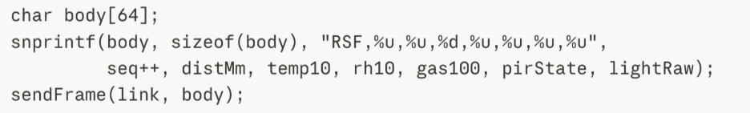
On the ESP32, a valid frame is split into fields with strtok:
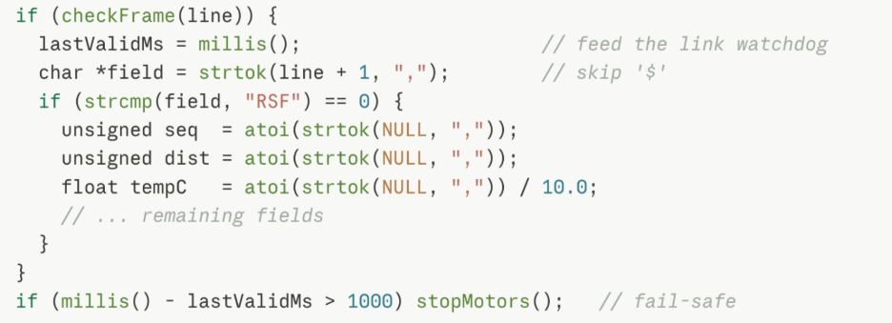Lines are collected with a non-blocking reader that adds one character at a time to a buffer and returns true only when a newline arrives, so neither board ever waits for the link.
7.8 Common Mistakes to Avoid
- Connecting the Uno's 5 V TX directly to the ESP32's RX pin.
- Forgetting the common ground between the two boards.
- Using %f in snprintf on the Uno, which prints ? instead of a number.
- Acting on a message before checking its checksum.
- Having no plan for a lost link, so the robot keeps driving on old data.

Practice Questions
- Why is the quadrature encoder connected to the ESP32 and not to the Uno in RoboSense?
- Calculate the XOR checksum for the body "OK" ('O' = 0x4F, 'K' = 0x4B) and write the full frame.
- How long does a 60-character frame take at 9600 baud with 8N1 format?
- Why does RoboSense send temperature as 251 instead of 25.1?
- Describe what each board does when the link is lost, and explain why this is safer than doing nothing.

